CPE 325: Intro to Embedded Computer System

**Lab01**

**Laboratory Assignment # 1**

**Submitted by**: Nolan Anderson

**Date of Experiment**: 08/27/2020

**Report Deadline**: 08/31/2020

**Demonstration Deadline**: 08/31/2020

# Introduction

Write a brief discussion on what the lab is about

Lab 1 is a simple introduction to the C coding language and making sure Code Composer Studio (CCS) is up and running correctly. This includes setting up the CCS Environment and two short coding assignments in C. The first task is to find the product of a number from n = 1 to n = 10, and output accordingly. You must call a function in order to output and calculate this data and use printf to do so as well.

**Theory**

**Topic 1**: To learn how to build, debug, and run a simple program in Code Composer Studio. This includes stepping through the program and monitoring what is happening on the device.

**Topic 2**: To learn how to make a simple flow chart diagram for a function call program in c. This includes using the correct shapes and descriptions for each step in the process.

**Results & Observation**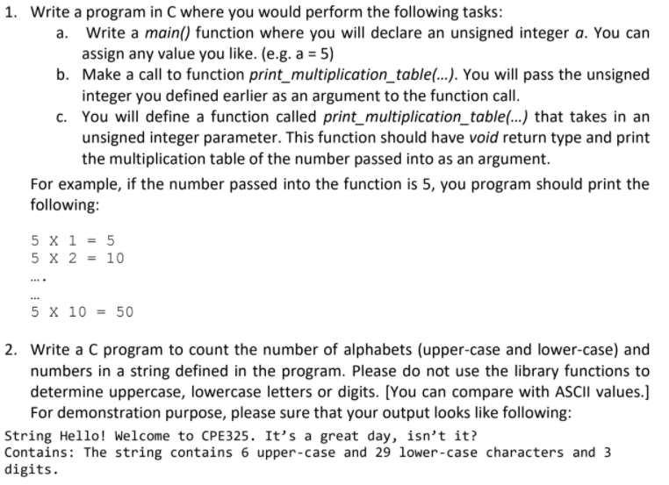

## Flow Charts:

**Flow chart Part 1**

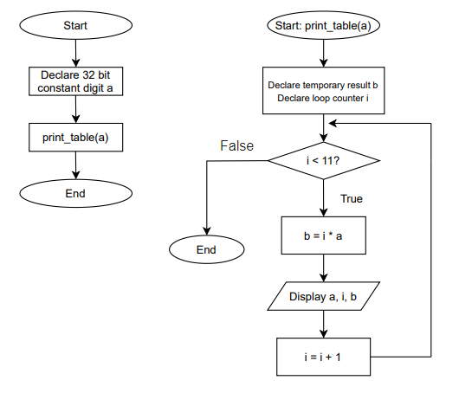

**Flow Chart Part 2:**

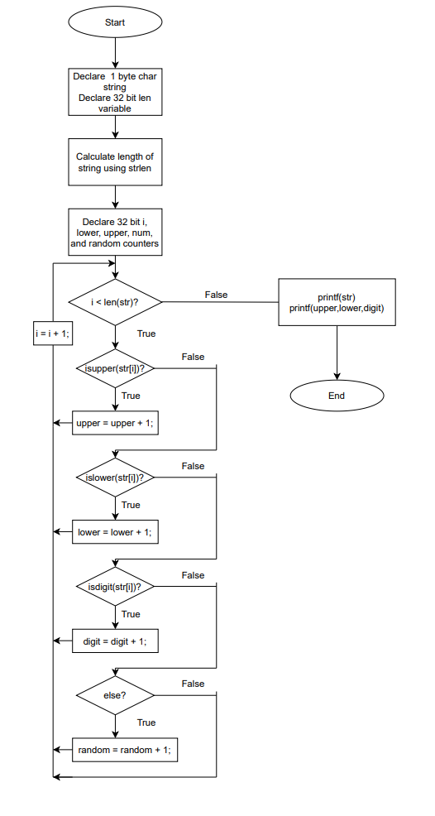

## Results Screenshots/Pictures:

**Lab 1, problem 1 console output:**

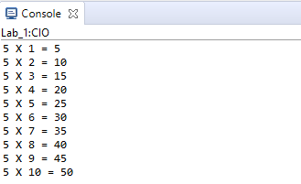

**Lab 1, problem 2 console output:**

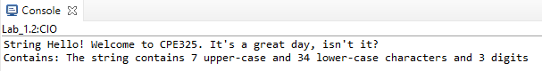

## Observations:

While attempting to run the code for part two, I noticed how important it is to change the properties of the project. For some reason, when I went to change the heap size it did not save. So when I tried to run the program, printf refused to work. I thought that was very interesting.

I also started to notice some of the differences in the c language which I have not used before. It is mostly the same the functions and include files are some that I have never used or seen before so I like this change a little bit. It offers a new challenge but at the same time not that difficult because it mostly works the same exact way.

I also figured out that project creation is very particular. For example, when I initially created the project, I used MSP430F5229 instead of the 5529 version, and it would not run whatsoever. You also cannot run the code unless the MSP430 is plugged in, of course.

# Conclusion

I learned how to properly build, use, and setup code composer studio and write a simple program in c. I also learned how to debug and get code composer studio to do exactly what I needed to. It was also nice to see the registers in action instead of just writing it down on a piece of paper. Really helps to seal what I have been learning and makes me excited to continue in this lab.

**VIDEO LINK BELOW:**

https://drive.google.com/file/d/16su0PoSuH0fDbEL6PxASeHijnjDTRnFG/view?usp=sharing

LAB 1 PROBLEM 1 C FILE

|  |
| --- |
| /*------------------------------------------------------------------------------  * Student: Nolan Anderson  * Program: Calculate the first 10 products of an integer  * Date: Aug 20, 2020  * Input: None  * Output: A multiplication table of the first 10 products of a predetermined number.  * Description: This C Program takes an integer variable and sends it to the function  * print_multiplication_table() and outputs the first 10 products of that  * integer. The integer is predetermined and no need for input.  *-----------------------------------------------------------------------------*/  **#include** <msp430.h>  **#include** <stdio.h>  // Function prototype  **void** **print_table**(**int**);  **int** **main**()  {  WDTCTL = WDTPW + WDTHOLD;  **int** a = 5; // delcaring a number to be multiplied by  print_table(a); // function call  }  **void** **print_table**(a)  {  **int** b; // temp variable to multiply  **int** i = 1; // for loop counter  **for**(i; i < 11; i++) // For loop to run through each number to be multiplied  {  b = i*a; // multiply the number by i  **printf**("%d X %d = %d \n", a, i, b); // output the data using print f  }  } |

|  |
| --- |
| /*------------------------------------------------------------------------------  * Student: Nolan Anderson  * Program: Calculate the number of Lower case, Upper Case, and integer values of a string  * Date: Aug 20, 2020  * Input: None  * Output: A string and its number of lower case, upper case, and integer values  * Description: This C Program takes reads a string and counts the number of lower case,  * upper case, and numbers. It outputs the string and the data.  *-----------------------------------------------------------------------------*/  **#include** <ctype.h>  **#include** <msp430.h>  **#include** <stdio.h>  **#include** <string.h>  **int** **main**()  {  WDTCTL = WDTPW + WDTHOLD;  **char** str[] = "String Hello! Welcome to CPE325. It's a great day, isn't it?"; // declare string variable  **int** len; //declare length of string variable  len = **strlen**(str); // get the length of the string using strlen  **int** i; // declaring initial variables and loop counters  **int** lower = 0; **int** upper = 0; **int** num = 0; **int** random = 0;  **for** (i = 0; i < len; i++) // for loop to loop through the string  {  **if**(**isupper**(str[i])) // check to see if the data at position i is upper case  {  upper = upper + 1;  }  **if**(**islower**(str[i])) // check to see if the data at position i is lower case  {  lower = lower + 1;  }  **if**(**isdigit**(str[i])) // check to see if the data at position i is a digit  {  num = num + 1;  }  **else** // check to see if the data at position i is a different character  {  random = random + 1;  }  }  **printf**("%s \n", str); // output initial string  // output the data of the string  **printf**("Contains: The string contains %d upper-case and %d lower-case characters and %d digits", upper, lower, num);  **return**(0);  } |

LAB 1 PROBLEM 2 C FILE